Creating the GitWork Branch and Committing hello.xml:
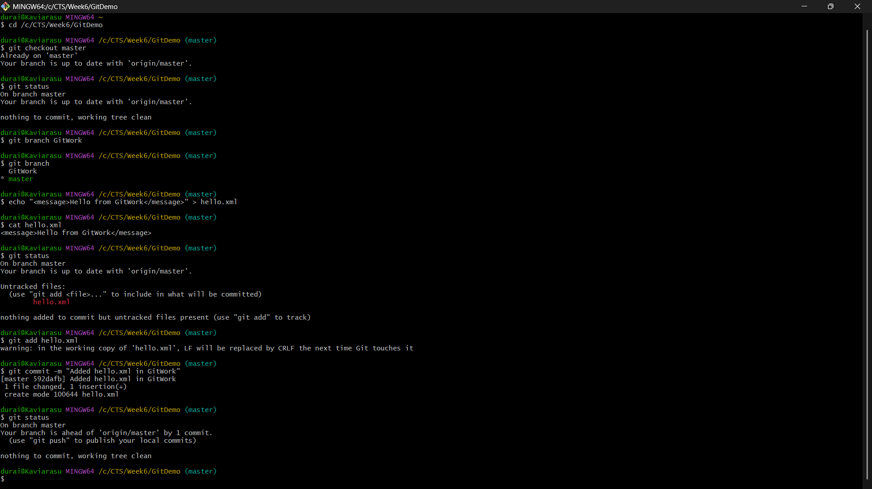
Switching to Master and Creating a Merge Conflict:
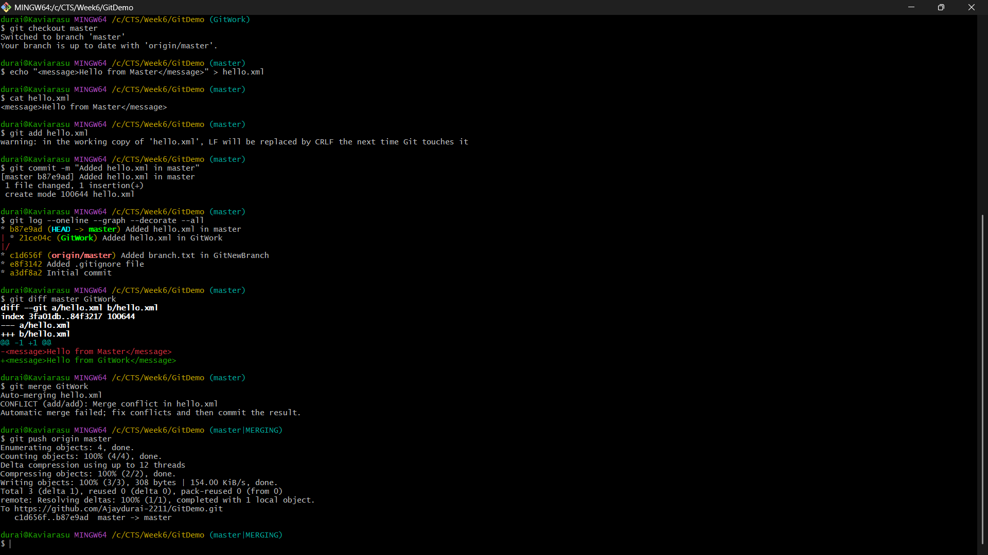

Merging the Branch, Detecting the Conflict, and Verifying the Repository:
